2018 STOCK MARKET CRASH WARNING  
  
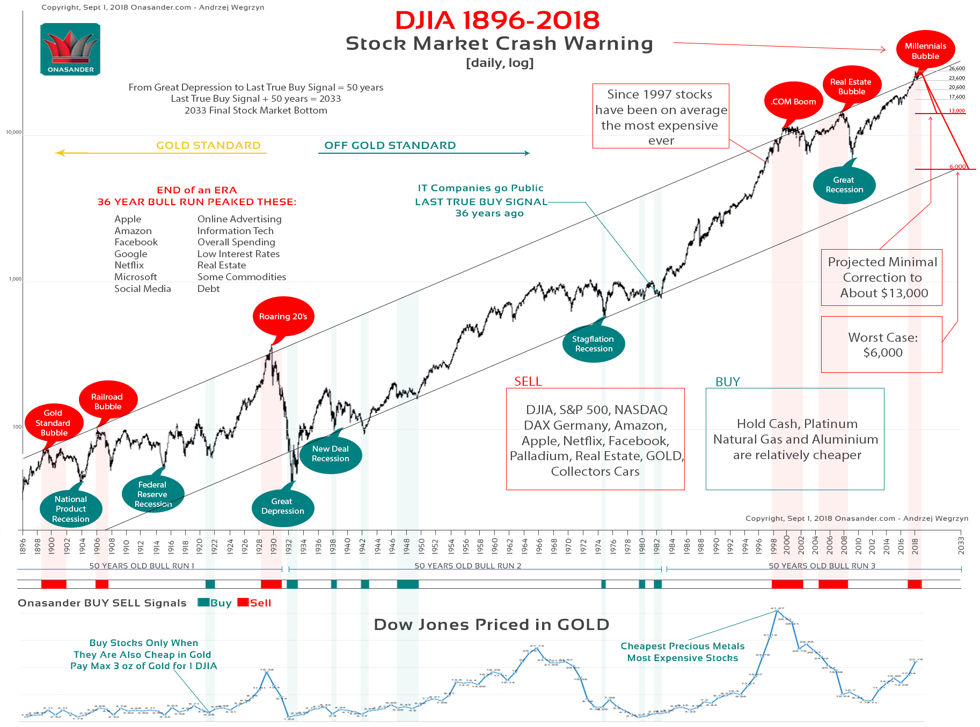

[ link to the full size pic: <https://onasander.com/images/trading/djia_crash.png> ]

The US Stock market and most other stock markets around the world are topping and will crash within the next 2 years. The US Dow Jones Industrial Average is overpriced just like it was right before the Railroad Bubble Crash, Great Depression, .COM Crash, and the Real Estate Bubble Crash.   
  
The upcoming recession is around the corner. Selling all overpriced assets and staying liquid is the ultimate trade at the moment. CASH WILL BE KING. Investors must be prepared for a 50% market correction before they can start buying stocks again.   
  
Stocks priced in Gold are in the SELL category with the DJIA price hovering around the same 22oz of Gold for 1oz of Dow Jones, as they were before the Great Depression.   
  
Follow Onasander https://onasander.com guide, and we will show you how to survive the upcoming recession, and how to benefit from it.